ONLINE CHAPTER

Domain Models

Learning Objectives

In this chapter you will learn
- the significance and purpose of a domain model
- how the domain model relates to other models in systems development
- how a domain model can be represented in UML

23.1 Introduction

In this supplementary chapter, we introduce the concept of a domain model and explain its purpose. A domain model primarily consists of classes that represent the most important and enduring concepts needed to describe the context and the operation of a business. Sometimes a domain model may also include models of processes, drawn using either activity diagram notation or Business Process Modelling Notation (BPMN). Domain models are closely related to analysis models but they exist at a higher level of abstraction. This is because they represent an analysis view of the organization, but they are not focused on the specific requirements of any particular application. As a result, the specification of classes in a domain model is often incomplete in comparison with the detailed view required to specify an application. Many organizations do not bother to maintain a domain model. This means that, when work begins on specifying and analysing the requirements for a new system, there is no library of partly defined analysis classes for the developers to draw upon. There is also no reference standard for the way that responsibilities should be allocated to entity classes. When a domain model does exist, it enables the reuse of previous relevant analysis work. It can also promote the consistency of models of different applications that may share common classes or behaviour.
.
23.2 What is a Domain Model?

A domain model represents the most important and enduring things, concepts, relationships and behaviour in the business domain as a whole. Often, a domain model is simply a class model that covers the entire business. It is rather like an analysis model, differing mainly in that it is not focused on a particular application. Instead, it models stable business concepts and relationships and aims at providing a foundation for the analysis models of many different application systems. Thus a domain model is more abstract and also likely to be more general than an analysis model. It is unlikely that it will include all the classes needed to create the analysis model for any specific application system, nor is it likely to contain all the details of those classes. This is because individual analysis models often involve data, or behaviour or both, that are specific to the requirements of the application. In addition, the requirements of any application system may change over time, and those details that are expected to be subject to change are unsuitable for inclusion in a domain model. Many of the detailed requirements may also be difficult to discover during the relatively high level fact-finding and analysis that generally produces a domain model.

23.3 Why Create a Domain Model?

Domain models serve two main purposes. First, they promote reuse. When a domain model exists, it can save quite a lot of time and effort for the developers responsible for creating the analysis model for a new application system. Second, they promote consistency and clarity in the way that the requirements for a new system are translated from use cases into software classes. In Chapter 7, we saw that the process of realizing a use case needs skill, care and judgement. Much of this difficulty relates to the identification of classes and their associations, and the preliminary allocation of attributes and responsibilities. A significant part of this work may already have been done in the process of creating a domain model. The task of the use case analyst may then become largely a matter of selecting appropriate classes from the domain model, New classes or other details need be added only only when the use case presents new requirements for behaviour or data that have not previously been documented.
A domain model is not expected to change much over time. This is the main point of having one at all. As a result, the investment made in creating and maintaining a domain model might be repaid many times over, as successive application systems projects benefit from reusing its elements. This can save the developers a great deal of effort, as successive projects benefit from analysis work that has already been done before.
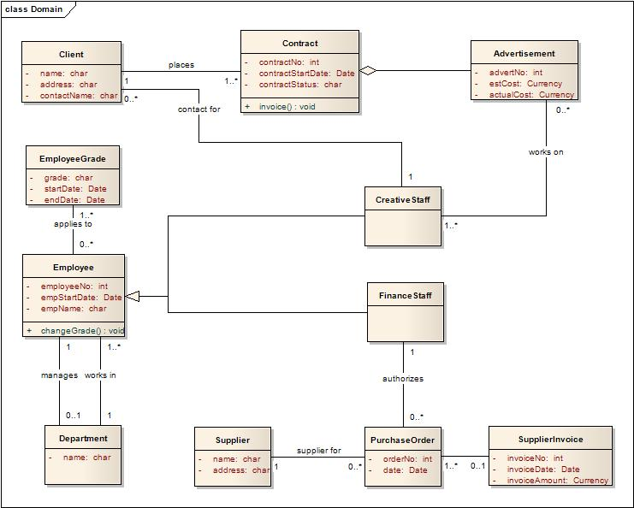

Figure 23.1 Partial domain class model for Agate

23.4 How is a Domain Model Represented in UML?

In many cases a domain model will consist of a single class diagram. Figure 23.1 shows an incomplete domain class model for the Agate case study.
The attributes and operations included in Figure 23.1 are a provisional view of the allocation of responsibilities to classes. This view may be refined in the analysis workflow for a particular application. For example, this may occur if the application requirements identify a need for data to be stored which is not already represented in the domain model.
A domain model ideally represents the behaviour of classes as well as their data storage responsibilities. This may mean only that operations are allocated to classes in the domain class diagram. Behavioural aspects may also be represented in activity or Business Process Modelling Notation (BPMN) diagrams of business processes. BPMN resembles activity diagram notation in many respects, but is specialised for the representation of business processes irrespective of whether there is any intention to automate them.

23.5 How Does the Domain Model Relate to Other Models?

The creation of a domain model may precede the construction of any particular application system. This means that it is an investment in potential future development projects. Or it may be derived directly from one or more analysis models. This means it is aimed at promoting the reuse at a later time of some of the analysis work done during a development project. In either case, whether it is created independently or derived from an application analysis model, it makes sense to review the domain model whenever an application model is being created for a new application. This helps to ensure that the domain model remains complete and correct.
Let us consider the Agate case study described in Chapter A1, and modelled in Figure 23.1, but without making any effort to relate our thoughts to specific application systems. Some concepts are clearly helpful in describing the nature of the business, both in terms of its structure and its operations. Some of these concepts represent people or entities that are either units within the business or that have some interaction with it. Among these, the most obvious ones mentioned in the case study are: partner, employee, department and client. Assuming that the company has suppliers (of materials, equipment, electricity and so on), it seems reasonable to add supplier to the list. These entities are necessary to any general description of Agate and the way that it operates. As long as Agate continues to operate within the same sector of industry, it is not likely that this will change. Therefore we can be confident in representing them with classes in the domain model. Some more abstract entities such as transactions and enduring relationships should also be represented in this way. Campaigns and advertisements are obvious candidates. So, too, are some other transactions that are not so clearly described in the case study (but only because they are not relevant to the campaign management system). We can expect these to include invoices to the company’s clients, purchase orders and payments to suppliers, employment contracts for staff, salary payments, and possibly a number of other conceptual entities.
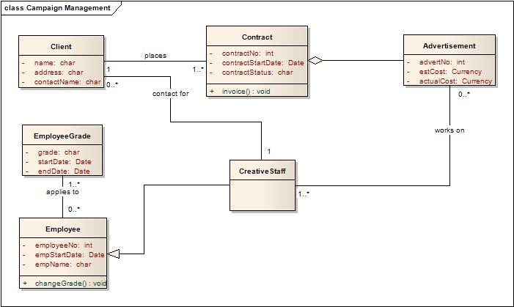

Figure 23.2 Partial analysis class model for Agate’s Campaign Management System.
The logical relationships between these entities are also unlikely to change in any significant way over time. The company will carry on sending invoices of some sort to its clients, and it will continue to be necessary to the client to whom each invoice has been sent. Other links will also remain important, for example that between a supplier and a supplier payment, between an employee and a salary payment or between an employee and the department in which she works.
Figures 23.2, 23.3 and 23.4 show various subsets of the domain classes as they might be imported into the models of different application systems.
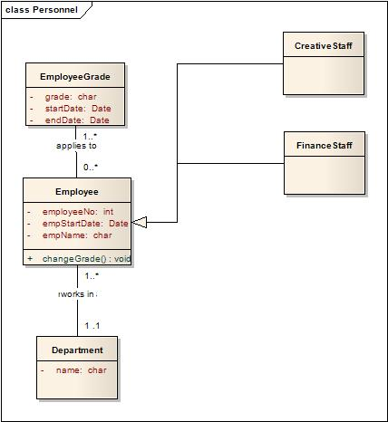

Figure 23.3 Partial analysis class model for Agate’s Personnel System.
23.6 Summary
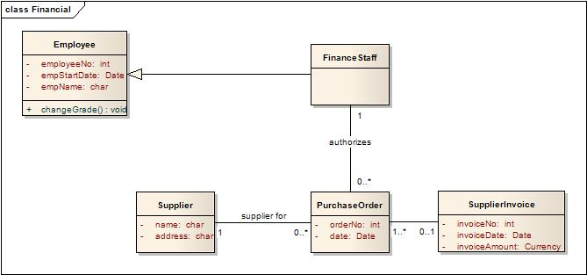

Figure 23.4 Partial analysis class model for Agate’s Financial Accounting System.
In this supplementary chapter, we have introduced the concept of domain models and explained their purpose. A domain model is in essence a representation of most important and enduring concepts that describe the context, structure and operation of a business. Domain models can be a useful source of classes and associations when developers need to produce an analysis model for a new abstraction. However, since domain models exist at a higher level of abstraction than an application analysis model, they are not focused on the specific requirements of that particular application. It is normal to expect to add to the specification of classes imported from a domain model. Domain models are not essential, and many organizations do not bother to maintain one. But they can save time and effort that otherwise must be spent specifying and analysing the requirements for a new system. In addition to their role in promoting reuse, a domain model can also be a useful guide to how responsibilities should be allocated to entity classes.

Further Reading

Fowler discusses the role of domain models in relation to the development of Enterprise Applications in his book (Fowler M., Patterns of Enterprise Application Architecture, Addison Wesley, 2002).
Evans describes an approach to systems development that is centred on the creation of a sound domain model (Evans, E., Domain-Driven Design - Tackling Complexity in the Heart of Software, Addison-Wesley 2004).
Oldfield’s online article discusses alternative approaches to domain modelling (Oldfield, P., Domain Modelling, 2002, at: http://www.aptprocess.com/whitepapers/DomainModelling.pdf).

